**Final Report: Does Femtech Work for Everyone?**

INTRODUCTION

The main objective of this project was to answer the question: does Femtech work for everyone? In order to dissect the question we needed to understand the size and growth of the Femtech industry, its usage amongst different groups of women, the things that Femtech is used for, and its impact on the healthcare outcomes that it aims to affect.

BACKGROUND

We began the research by exploring a preliminary dataset looking at the association between gender and the differences in outcomes of a chronic disease. The purpose of conducting this preliminary exploratory analysis was to see if we could provide a potential reason for the rise and popularity of the femtech industry. Using a t test the key finding of this preliminary research was that there is no statistical significance. The p value obtained was 0.05. Thus meaning we had to accept the null hypothesis in that there was no correlation in role of gender impacting the clinical outcomes.

Following on we continued onto the secondary stage of our research and we were able to find evidence of the growth of the Femtech industry and its funding within the digital health landscape. This justified its relevance as an emerging industry and is shown in figure 1, below.

**Figure 2.** Funding of select sectors within Digital Health over time

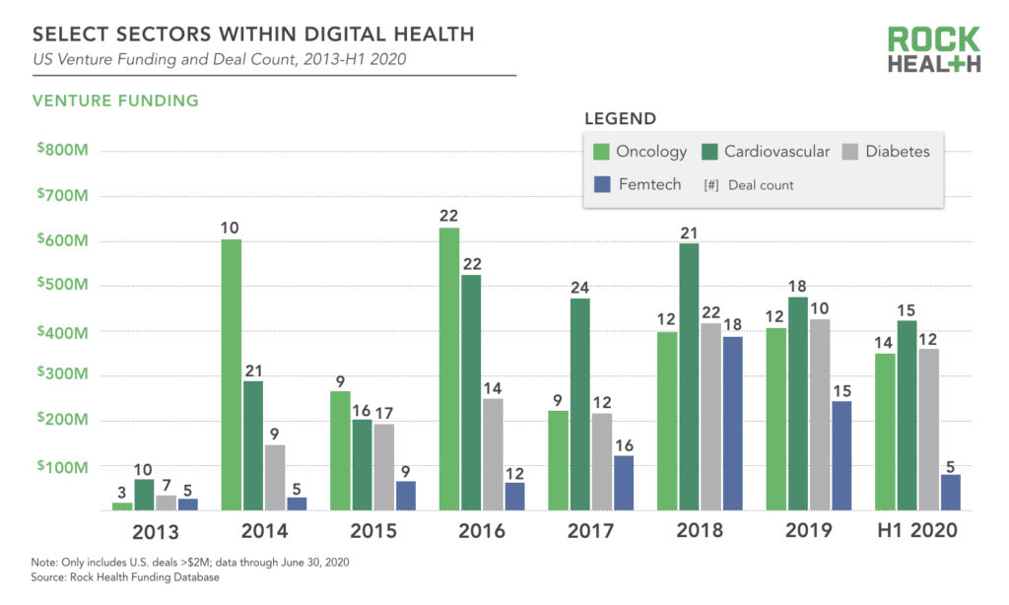

We identified fertile women as the target audience in the Femtech industry, demonstrated by the fact that fertility and pregnancy shared significant market share in the Femtech industry, shown in figure 2 below. This helped to guide our data collection as we then focused on these sectors when choosing our datasets with a specific focus on contraception.

**Figure 2.** Femtech Companies by Sector

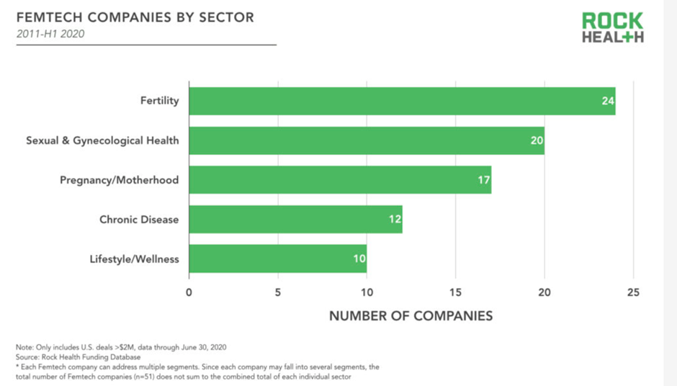

With our new focus on contraception, we wanted to better understand the key people using different types of contraception, using demographic factors of age, ethnicity, geography and socioeconomic status to provide us with the statistics to adequately analyze its effectiveness. We also wanted to determine whether Femtech was currently meeting people’s needs, and what the forecasted predictions for the future of Femtech were.

This research is intended to help medical professionals and Femtech entrepreneurs see how Femtech works for the general population in the UK, how it impacts usage of other methods of contraception, and whether the sector is predicted to continue to grow. It is hoped that the results of this report could help to identify gaps in the Femtech market in terms of specific demographic groups.

Data preparation required extensive work. We used datasets that corresponded to the identified sectors: fertility and contraception and analyzed the changes, demographics and usage over time. We used csv files and the pandas library to work with the data as tables, and the NumPy library to perform calculations where necessary. We were also able to calculate growth trajectories of Femtech over time, correlations between that growth and other factors as mentioned above, and comparisons of factors such as the demographics of those buying different types of Femtech. The data collection will need to have compatibility to the software we will be using, for instance tabular data or CSV files will work for our python data software. After data collection we need to clean and transform the data, especially if we choose to compile our own data into databases.

STEPS SPECIFICATIONS

Our team split the data sources we wanted to use between the three of us to research and find relevant data for the questions we wanted to answer. These data sources, set out in our project outline, were:

* Google Dataset Search
* Kaggle
* Global Health Observatory Data Repository
* ORCHA Health
* NHS Digital Data

We took 2 days to search these data sources before reconvening to discuss what we had found. We had found data sources in different forms and discussed how we could combine these to create a usable dataset that would answer our questions. It was decided that we would each work on the individual datasets that we had found in order to answer different questions set out in our project outline.

One team member worked with a dataset from the NHS on contraceptive services over time, found through searching the NHS Digital Data website for key terms such as “pregnancy” and “contraception”. This data was in the form of a readable Excel report and included data points such as growth of different contraceptive methods over the last 10 years, their uptake by women of different ages, and their usage across different regions in the UK. It was decided that “Natural Family Planning”, a variable in the report, could be used as a proxy for the rise of Femtech apps, since many of them focus on tracking the menstrual cycle for fertility reasons.

First, one team member trawled through the Excel report to find the most useful data points. They then split the data into several separate datasets covering different aspects of the data that would be used for analysis. To create these new datasets, they copied the data from the original Excel sheet into a new Excel sheet, gave the columns appropriate variable names, and saved the sheets as csv files. They then imported the data into Python using the pandas library and checked the shape, key information, and look of the data to ensure that it was usable. There were no anomalies in the data and no NaNs, so we could proceed with analysis.

Through internet search, we also found a very simple report detailing the growth of investment in Femtech over time, which we cleaned in order to use for a prediction of growth for the next 5 years. Finally, we imported some data on the stock prices of two major US Femtech companies, Natera and Progyny, using the Tiingo API.

The questions we set out to answer with this data analysis, and methods of analysis, are set out below.

**How has the usage of natural family planning in the UK grown over time compared to other contraceptive methods? Is there a negative correlation between the number of emergency contraceptives prescribed and the growth of natural family planning? Did the COVID-19 pandemic influence how people access sexual health advice?**

For these questions we used a dataset called “contraception_over_time.csv” which shows the number of females using various contraception methods every year since 2010. We calculated the mean percentage of people using natural family planning over time using the statistics package, and then used matplotlib to plot line graphs comparing the trajectory of different variables over time. Finally, we used matplotlib to create a pie chart showing the percentage of people who were new to natural family planning in 2021 compared to those who were already using it.

**Who is most likely to use natural family planning? Are certain contraceptive methods more prevalent amongst certain demographic groups?**

To answer these questions, we used the “regional_data.csv” dataset. We used seaborn and matplotlib to plot bar charts showing the % of females using natural family planning by age group and by region. We then used matplotlib to create subplots showing the correlation between demographic variables and contraceptive methods.

**How has investment in Femtech grown, and how is it predicted to grow over the next 5 years?**

For this question we used the Tiingo API to import data on stock prices of two major US Femtech companies and plotted this over time.

Then, we used the seaborn library to plot the existing investment in Femtech over time using the “investment.csv” dataset. We employed the adfuller package from statsmodels to check whether my data is stationary, then split the dataset into a training dataset and a testing dataset. We created a SARIMAX forecasting model using the statsmodels and pmdarima packages. We looked at the residuals of my model to check its robustness, then used the pandas library to forecast growth of investment in Femtech over the next 5 years.

IMPLEMENTATION AND EXECUTION

Our planning stage was the most thorough stage, moving from our big topic of Femtech to more smaller questions on contraception and family planning required several pivots. We ideated and brainstormed through our shared interest in the medical healthcare space, identified problems with discrepancies in gender/ race/ socioeconomic biases and decided on adequate data analysis in an attempt to provide some solutions. The output from this stage was a concise project plan with a 2 week plan, with specific task allocation to each team member for subsequent topic areas.

The main requirements were the accessibility of our data, the Femtech industry proved to have scarce public data.One of the main challenges was to find enough datasets as it is critical to have an adequate sample size while performing an analytical study. In order to formulate reliable results as well as make the results more generalisable. Using a smaller dataset meant it was difficult to find meaningful links in the data because the sample size was too small. Statistical tests often demand a bigger sample size to verify that the sample is representative of a community and that the statistical conclusion can be extended to a wider population.

Another issue was the availbility of the data. Most of the most relevant datasets were not available to us for free. In order to solve this problem we had to alter our questions slightly and align them towards the data sets that we were able to access. Streamlining our initial requirements from several questions surrounding Femtech to solely contraception allowed for clearer objectives, and report findings. Another challenge we faced was we had no access to previous research studies on the subject.Using prior studies helps to provide the theoretical underpinnings for a research project. In this scenario we tried to show the need for future research into this topic as we believe there are many research gaps.

The architecture and design of the project was a labored process. We chose a clear framework of using specific datasets to answer specific questions using a range of tools and libraries. We did this in a chronologized way with each data set we interacted with and then using our coding tools we then tested the data and predicted an outcome.

We adopted a scrum like development approach, acted as a self managing team with each having a certain level of autonomy of the work, meeting every few days to show work done and highlight any problems. We used the Slack application to detail all project processes, and correspondence, as well as Google drive and Github repositories to upload code.

We differentiated our team member roles based on strengths and interests. One team member proved to be great at data analysis, particularly data preparation to make sense of the contraceptive datasets for our report. Another member organized the information, detailing out the key insights from our broad topic and checking if the initial question was answered. Our last team member proved to be great at data analysis, particularly critical analysis of the Femtech industry. We were able to access and edit each other's work and did not suffer with many issues with the code.

**RESULTS**

Our results showed that the use of natural family planning has grown over time, but that it remains small. When comparing against all other methods of contraception, natural family planning is the only method of contraception to have grown, with oral contraceptives declining in popularity and emergency contraception also declining, shown in figure 3 below. This suggests that women are increasingly turning to new methods of contraception, which is a good sign for the growth of Femtech apps, also supported by the fact that the majority of women (51.7%) using natural family planning are changing from their existing contraceptive method. It also suggests that women are using natural family planning methods effectively, since there is a lower need for emergency contraception. This graph shows that natural family planning remains extremely small compared to other methods, but if the trajectory of all these methods continues, we could see it become a leading contraceptive method in the near future.

**Figure 3.** Usage of different contraceptive methods over time in the UK.

In order to see whether natural family planning works for all, we investigated the uptake of natural family planning according to age and location in the UK, shown in figure 4 below. Interestingly, those most likely to use natural family planning are older, with women aged 45+ using it the most. This is contrary to other contraceptive methods which are most likely to be used by those aged 20-34. There is no clear pattern as to regional use of natural family planning, suggesting that it can work for all in terms of location at least. In order to dig into the demographics of those using natural family planning a bit more, we plotted some scatter graphs to show the correlation between uptake of natural family planning and poverty rate, ethnicity, income, and urban location. Due to the relatively small percentage of women using natural family planning in each region, there was no clear correlation between any of these demographic variables and its usage. Whilst this could be evidence that natural family planning works for everyone, the low variability in the data and the relative infancy of natural family planning means that this analysis should be repeated when more data is available before drawing true conclusions. The scatter plots are shown in figure 5.

**Figure 4.** Uptake of natural family planning by age group and UK region.

**Figure 5.** Scatter plots showing correlation of demographic variables and uptake of natural family planning in the UK.

Taking all this into account it seems that, although natural family planning is becoming more popular as a contraceptive method, it still remains small, making it difficult to decide whether it truly works for all women. As Femtech continues to grow, more data should be collected on the intersectionality of natural family planning and app usage in order to draw conclusions as to their efficacy. Luckily, we can expect that Femtech will continue to grow as investors see its potential, raising hopes for more data in the future. Figure 6 shows our forecast for the next 5 years, predicting that investment in Femtech could grow to almost $1.5bn by 2026.

**Figure 6.** Forecasted growth in investment in Femtech over the next 5 years.

References

Rock Health Funding Database

Femtech companies